

**PolySite**

|  |  |  |
| --- | --- | --- |
| **Supervisor:** | *LÊ THANH NHÂN* | |
| **Semester:** | *01* | |
| **Batch No:** | *T5.2410.E0* | |
| **Group No:** | *07* | |
| **Order:** | **Full name** | **Roll No.** |
| *1.* | *Huỳnh Quốc Huy* | *Student1614876* |
| *2.* | *Lê Thị Hạnh Mai* | *Student1614875* |
| *3.* | *Lê Trung Hiếu* | *Student1614896* |
| *4.* | *Trần Hoàng Anh* | *Student1614884* |

***Month****: 01* ***Year****: 2025*



This is to certify that

|  |  |
| --- | --- |
| **Mr.** | **Huỳnh Quốc Huy** |
| **Ms.** | **Lê Thị Hạnh Mai** |
| **Mr.** | **Lê Trung Hiếu** |
| **Mr.** | **Trần Hoàng Anh** |

Have successfully Designed & Developed

|  |  |  |
| --- | --- | --- |
|  |  |  |
| **POLYSITE** | | |

Submitted by:

|  |
| --- |
| **Mr. LE THANH NHAN** |

Date Of Issue:

|  |  |
| --- | --- |
|  |  |

Authorized Signature:

|  |  |
| --- | --- |
|  |  |

|  |
| --- |
| **Content** |

Content

Acknowledge

Synopsis

Review1 (2-7)

Review2 (8-9)

Review3 (10-27)

Checklist of Validation (28)

Submit checklist (29)

Tasksheet (30)

|  |
| --- |
| **Acknowledge** |

As we understand that the eProject is a step-by- step learning environment that closely simulates the class-room and Lab based learning environment into actual implementation. It is a projectimplementation at your fingertips!! An electronic, live juncture on the machine that allows you to.

* Practice step by step i.e. laddered approach.
* Build a larger more robust application.
* Usage of certain utilities in applications designed by user.
* Single program to unified code leading to a complete application.
* Learn implementation of concepts in a phased manner.
* Enhance skills and add value.
* Work on real life projects.
* Give a real life scenario and help to create applications more complicated and useful.
* Mentoring through email support.

We would like to send a great thank to our professor and others student for the addorable supports during the time in project.

Beside serveral mistakes we had made in the project, we hope to have more oppotunities to widen our knownledge in web developing world.

We also thank you so much for your infomation and the “demo” project from India APTECH to help us get more reality experience in this project. Since we have gained more experience from this project, we will not stop learning any thing as much as we can to be more successful in the future.

Your Sincerely,

Team Group 07.

|  |
| --- |
| **Synopsis** |

The Objective of this program we aim is to give a sample project to work on real life projects. These applications help us build a larger more robust application.

The objective is not to teach us HTML/JavaScript but to provide us with a real life scenario and help us create basic applications using the tools.

Hence, we can revise the chapters before we start with the project.

This project is meant for students like us who have completed the module of HTML5. These programs should be done in the Lab sessions with assistance of the faculty if required.

The website sells plastic bottles, offering a variety of sizes and designs to meet both personal and industrial needs. The bottles are made from safe, durable materials, ensuring reliability and user-friendliness.

It is very essential for us that will have a clear understanding of the subject. We think we should go through the project and solve the assignments as per requirements given.

And get back ***eprojects@aptech.ac.in*** as the assigned schedule.

|  |
| --- |
| **Problem Definition** |

PolySite is a company specializing in the production, supply, and export of various types of PET, PP, and PC bottles used in diverse industries such as packaged drinking water, household chemicals, pharmaceuticals, cooking oil, alcohol, hair care, and pesticides. To enhance their online presence and streamline interactions with customers, PolySite requires a comprehensive website that effectively showcases their products and services.

We need to design a SPA and responsive website with the following criteria:

1. User-friendly, where customers can easily navigate through product categories, view detailed specifications and pricing, browse a collection of images, provide feedback, and access contact information. Additionally, the website will allow users to download detailed product descriptions in PDF or DOC.
2. The website consists of a set of pages and menus that represent the choice of activities to be performed. Pages, menus, and other visual elements must be designed in a visually appealing way with attractive fonts, colors, and animations. All of these should also be presented in a responsive manner.

3. The menu is well-designed with necessary submenu options.

4. Consistent color scheme throughout the website.

5. Smooth navigation across all pages

**The structure, interface, and functionality of the website**

1. Home page:

- Display the company logo.

- Include a navigation bar with: Home, About Us, Products, Services, Gallery, Contact Us, Feedback.

- Include a brief introduction with a "see more" button that navigates to the About Us page.

- Contains a type of bottle along with a representative image; clicking on the image will navigate to the corresponding bottle page in Products.

- Contains information about various services offered by PolySite to attract potential customers and partners (including images, service names, and a navigation button to the detailed page).

- Contains a footer divided into 4 sections with the following information: Headquarters, Branches, Google map (occupying 2 sections)

1. About Us

- Information about PolySite, its history, mission, and values.

1. Products

- Detailed pages for different bottle categories with images, specifications, and pricing information.

- Includes a download button: an option for users to download the full product description as a PDF or DOC file for offline access.

1. Services

- Information about the various services offered by PolySite to attract potential customers and partners.

1. Library

- A visual display room showcasing various bottles and packaging solutions offered by PolySite.

1. Contact Us

- Contact information and a form to reach out directly to the company. Display contact details and location using a Geolocation API.

1. Feedback

- Allow customers to give feedback on the company's products and service

|  |  |  |  |  |  |  |  |  |  |  |  |  |  |  |  |
| --- | --- | --- | --- | --- | --- | --- | --- | --- | --- | --- | --- | --- | --- | --- | --- |
| |  | | --- | | **Customer Requirements Specifications** |  |  |  | | --- | --- | | **User:** | | |  | **input:** | |  | * Provide feedback on the experience of using the website, including any issues encountered and suggestions for improvement. * Use search engines to find information and products, thereby generating user behavior data. | |  | **Process:** | |  | - Send customer feedback to the repository  - Search for products according to the information provided by customers in the system | |  | **Output:** | |  | - Popup responds successfully  - Show products that look like potential customer information | |

|  |  |
| --- | --- |
| **Webmaster:** | |
|  | **Input:** |
|  | * Collect access data from Google Analytics and Search Console * Gather server logs and system data * Collect information from SEO tools and CRM * Gather feedback from users |
|  | **Process:** |
|  | * Process data from Google Analytics and Search Console * Process server logs to detect errors and security issues * Process SEO data to optimize content and improve search rankings * Process user feedback to enhance website experience and interface |
|  | **Output:** |
|  | * Generate performance reports on user access and behavior to enhance website operational efficiency. * Export a list of keywords and content that need optimization. * Export security error alerts and a remediation plan.   - Export charts and reports for visualizing SEO data. |

|  |  |
| --- | --- |
| **Hardware / software requirement:** | |
|  | **Software:** |
|  | * Intel Core i3/i5 Processor or higher * 8 GB RAM or above * Color SVGA * 500 GB Hard Disk space * Mouse * Keyboard |
|  | **Hardware:** |
|  | Technologies to be used:   * Frontend: HTML5, CSS, Bootstrap, JavaScript, jQuery, React/AngularJS, Figma, XML * Data Store: JSON files or TXT files   Other Requirements:   * Operating Portal: Windows * Browsers: Edge, Chrome, Mozilla Firefox, Safari |

|  |
| --- |
| **Architecture and design of the project** |

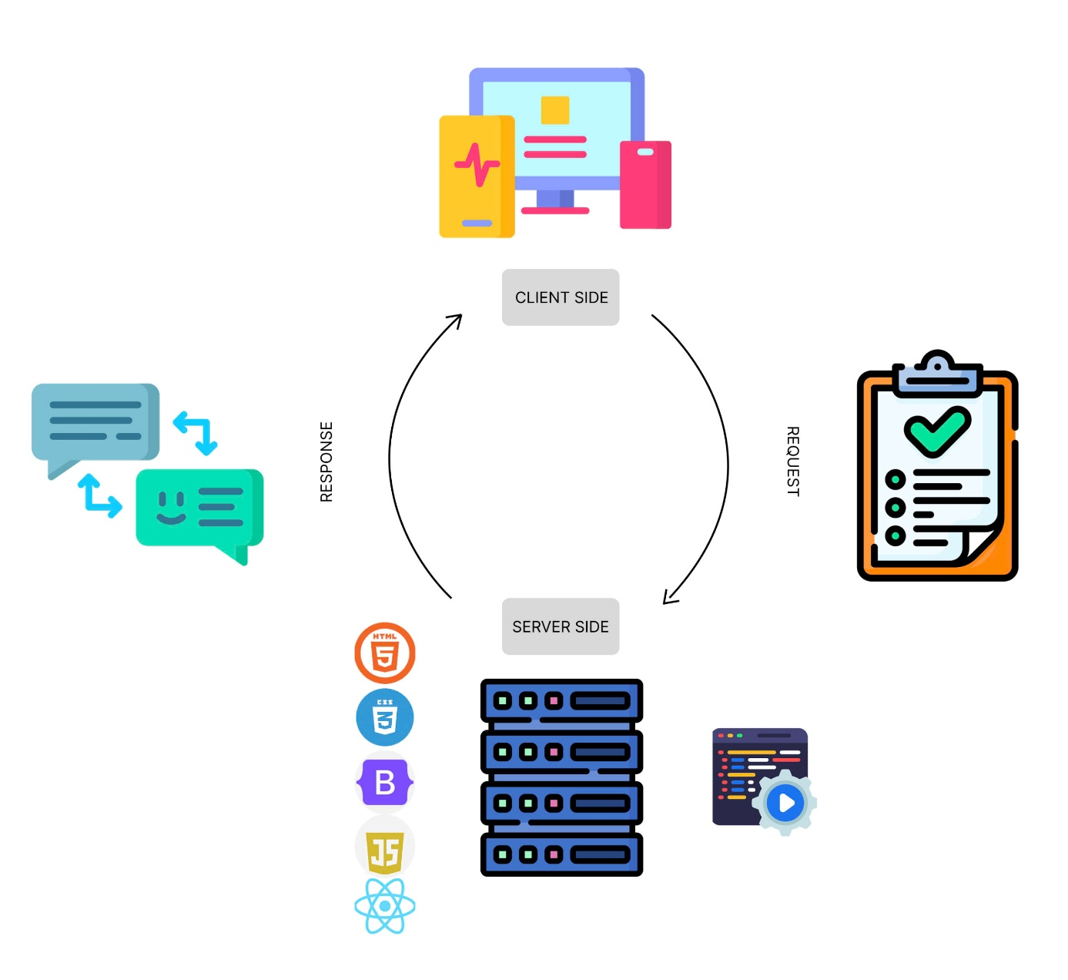

|  |
| --- |
| **SiteMap** |

SERVICE 2

SERVICE 1

BOTTLE 2 TYPE 2

BOTTLE 1

FEEDBACK

CONTACT US

LIBRARY

SERVICES

PRODUCTS

ABOUT US

HOME

|  |
| --- |
| **Screen shots** |

1. **Home Page:**

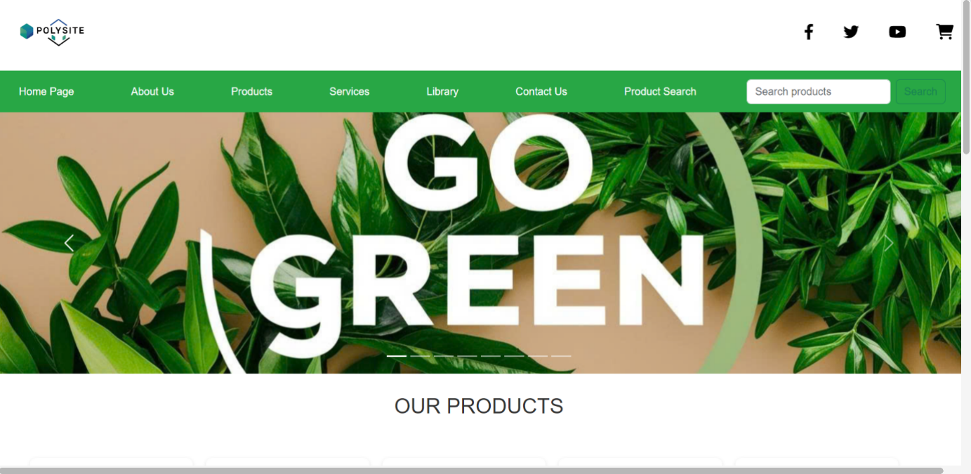

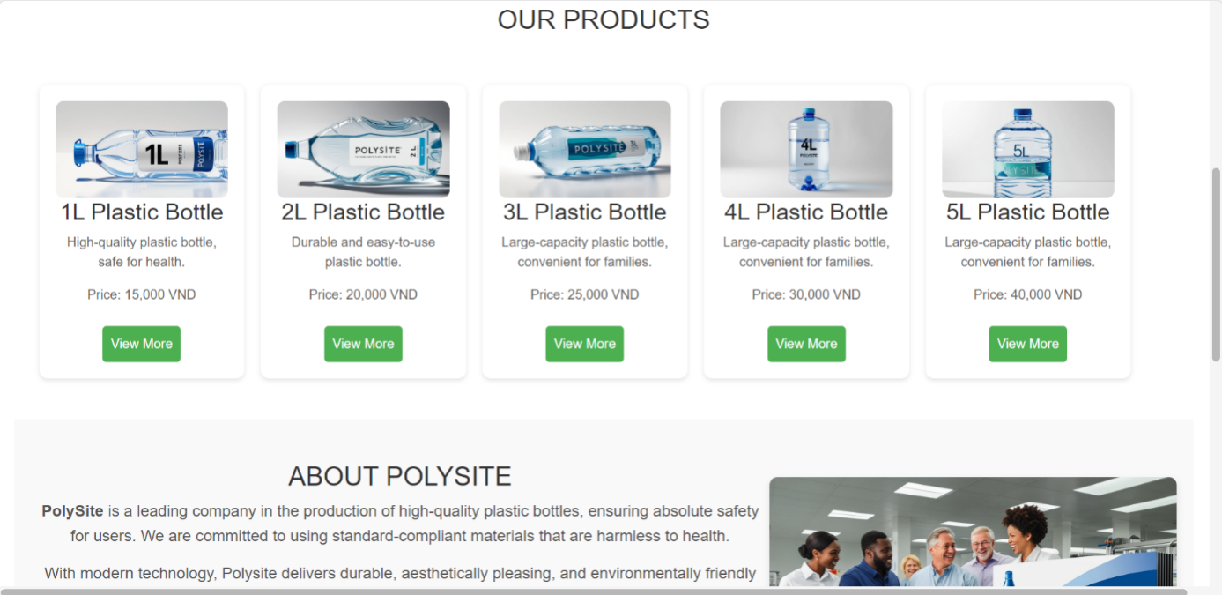

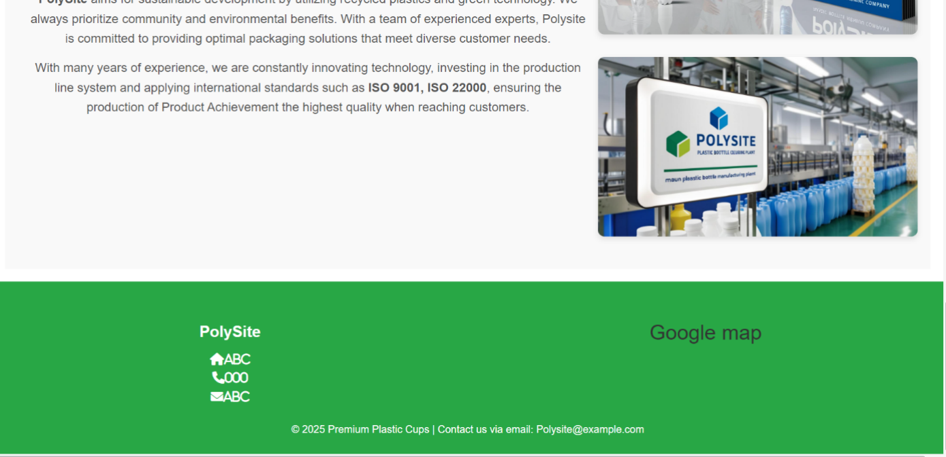 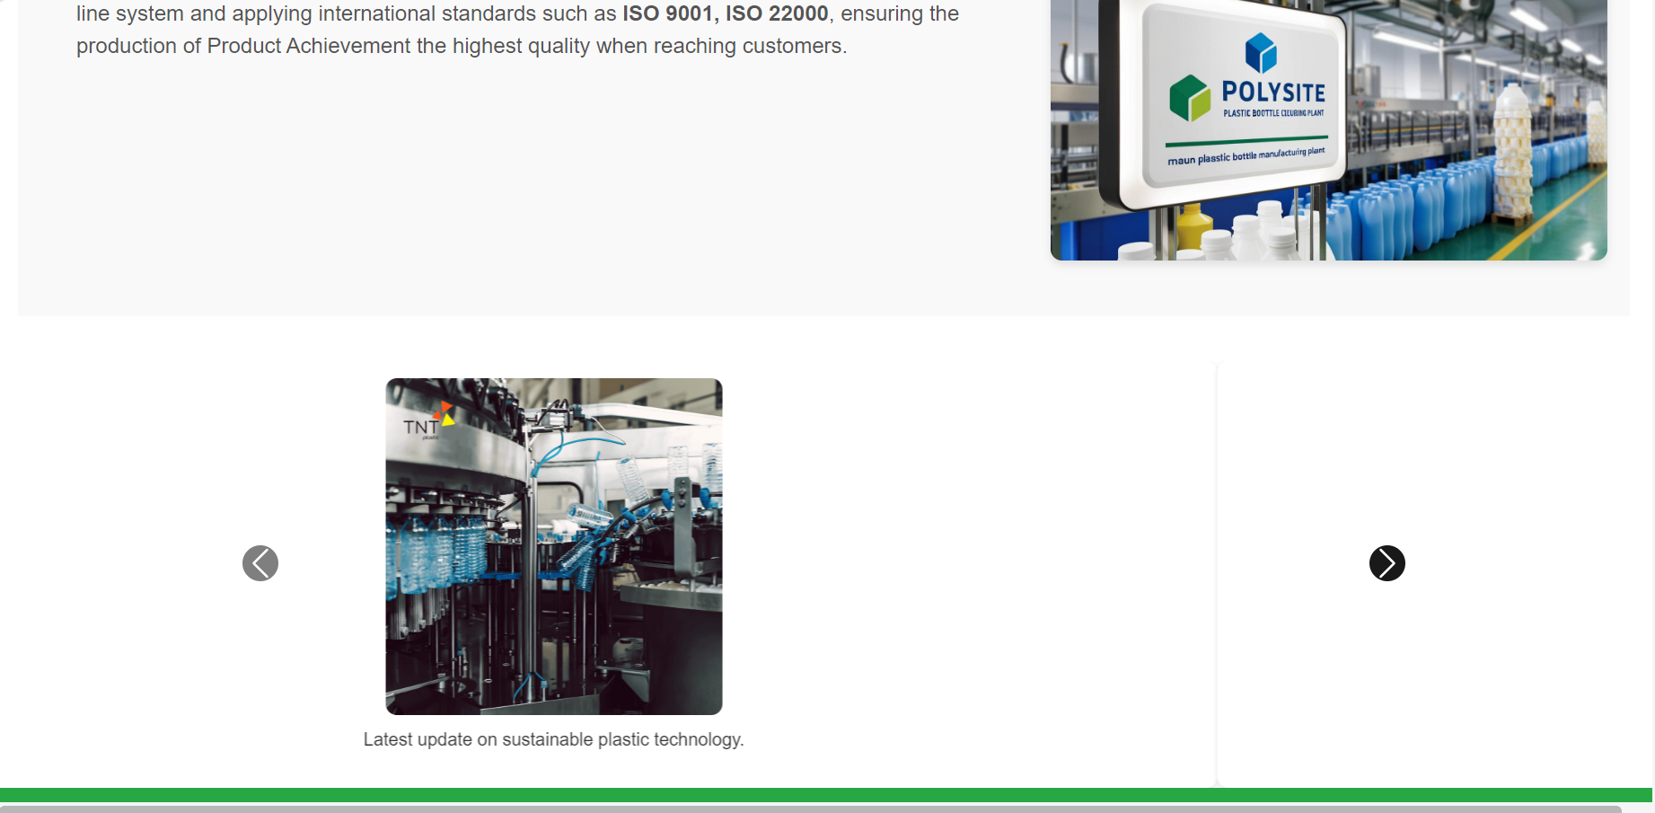

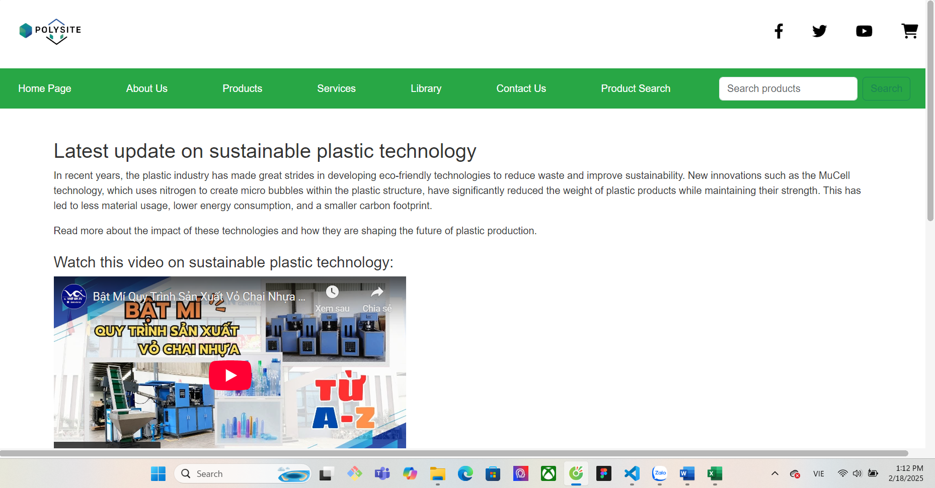

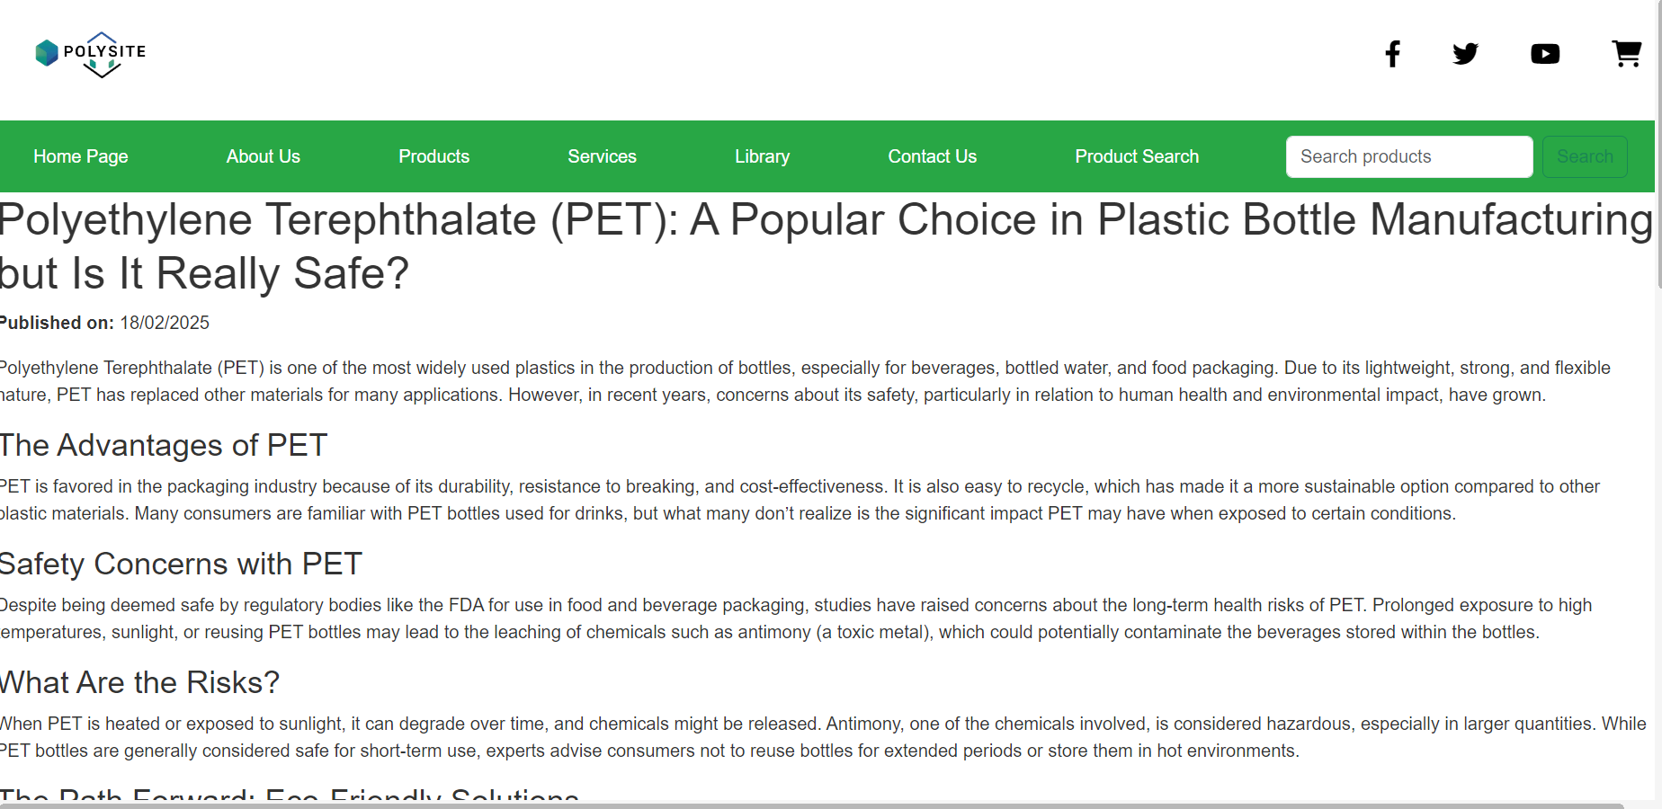

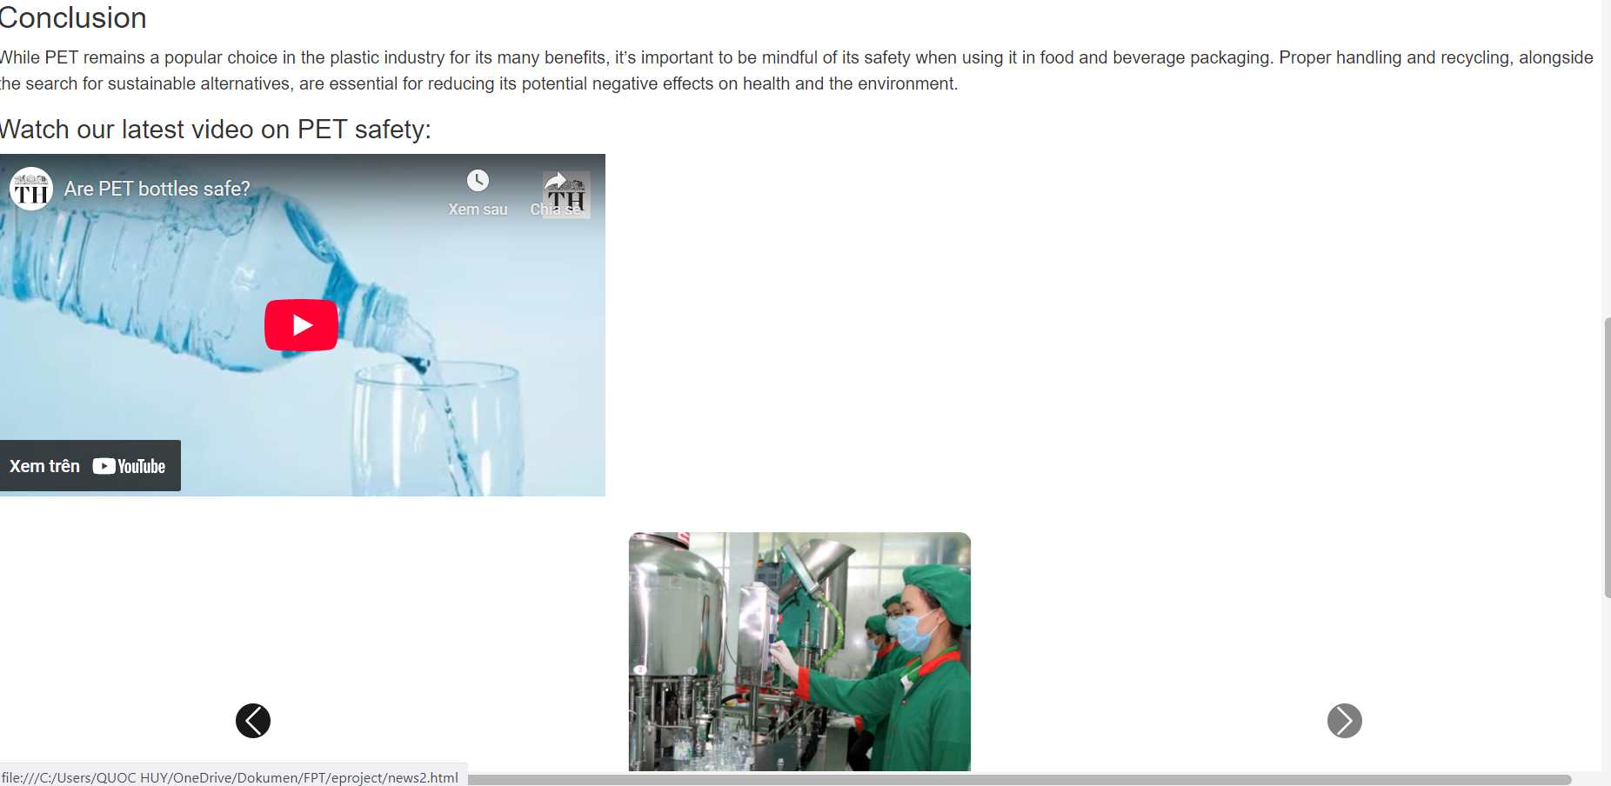

**Description:** This is a website that contains information about PolySite **From:** Open from any other page with a menu bar  
**To:** From this Homepage it is possible to open any other website that is in the menu bar

1. **About Us:**

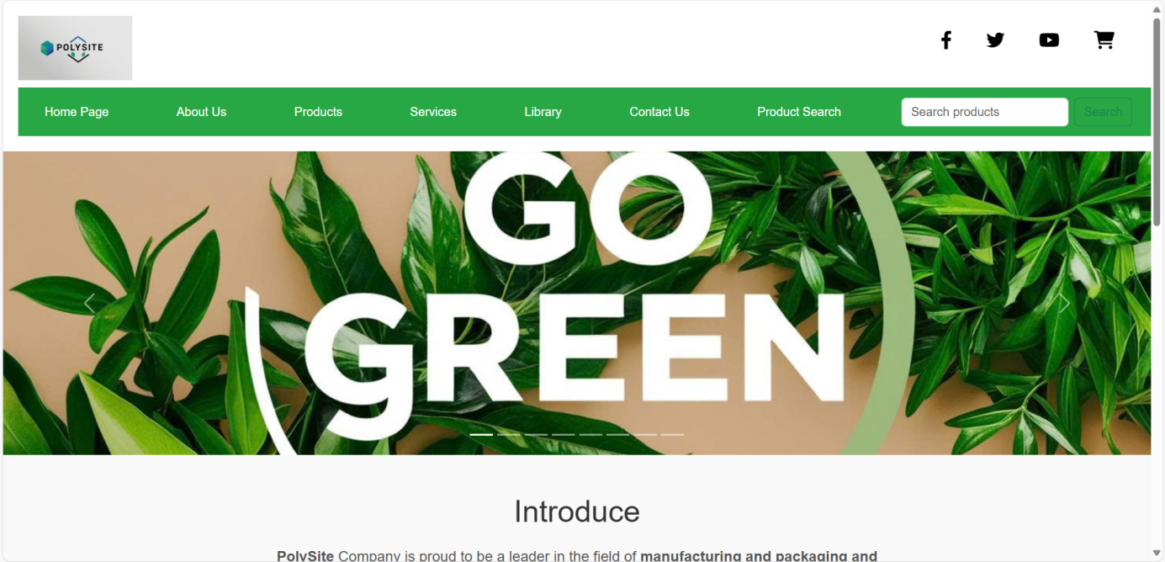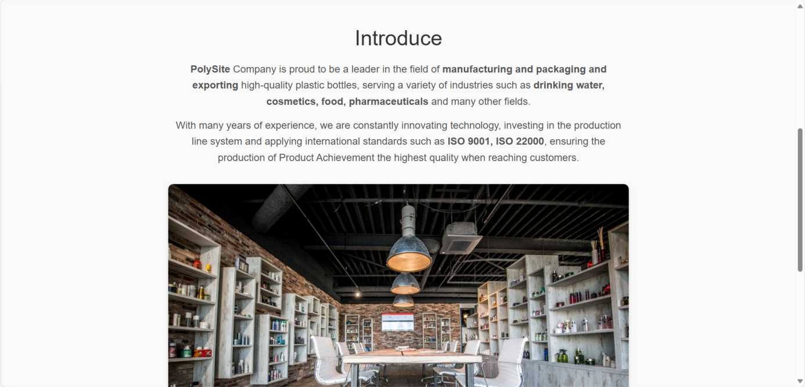

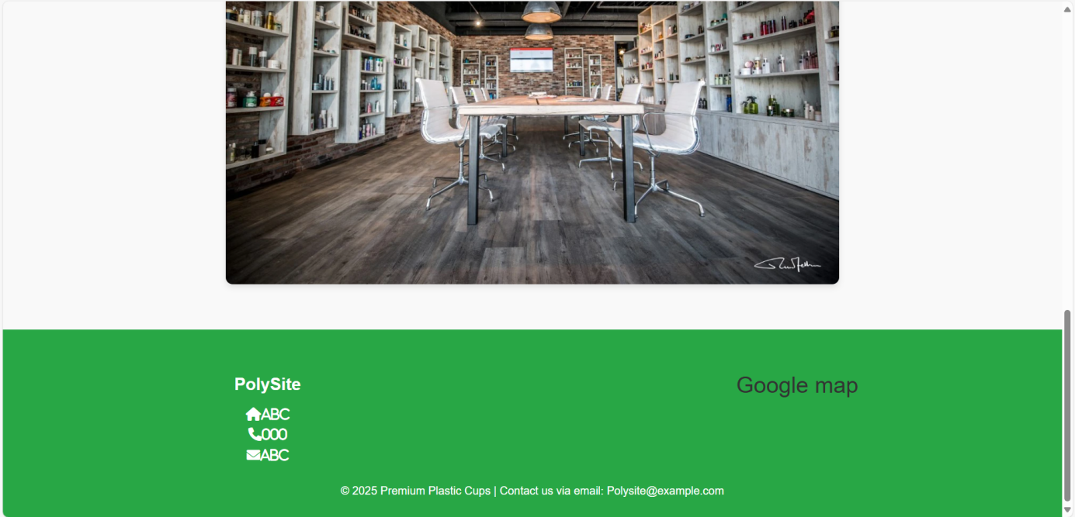**Description** : This is a website that contains information about PolySite

**From** : Open from any other page with a menu bar

**To** : From this website it is possible to open any other website that is in the menu bar

1. **Products:**

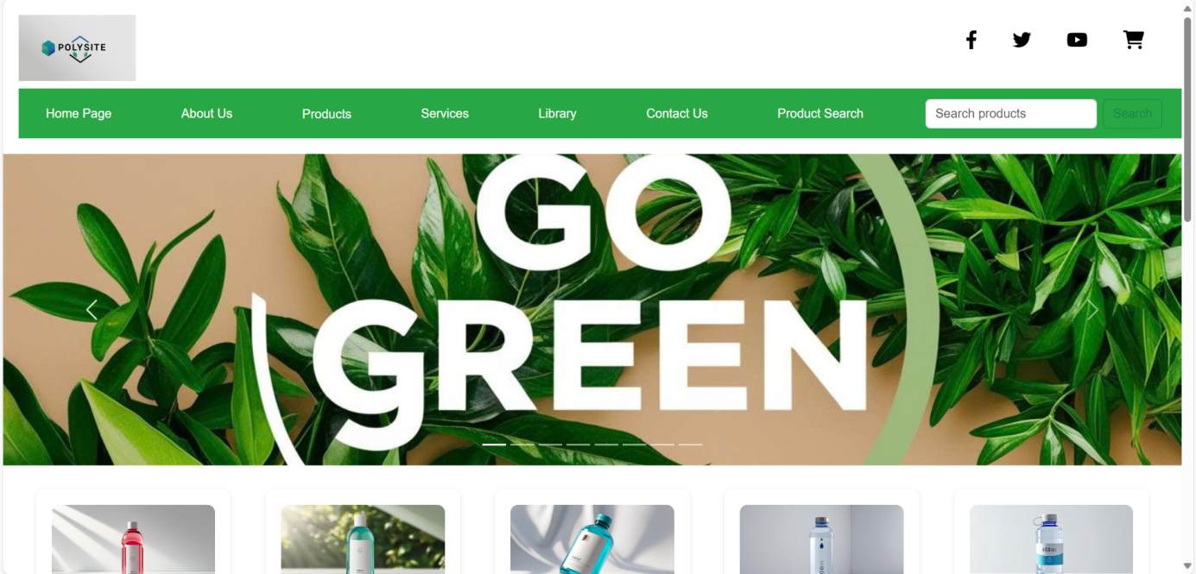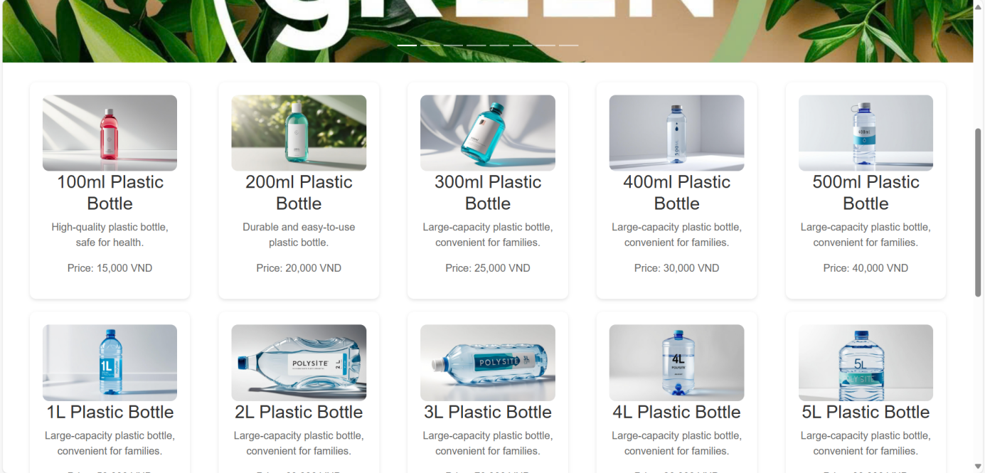

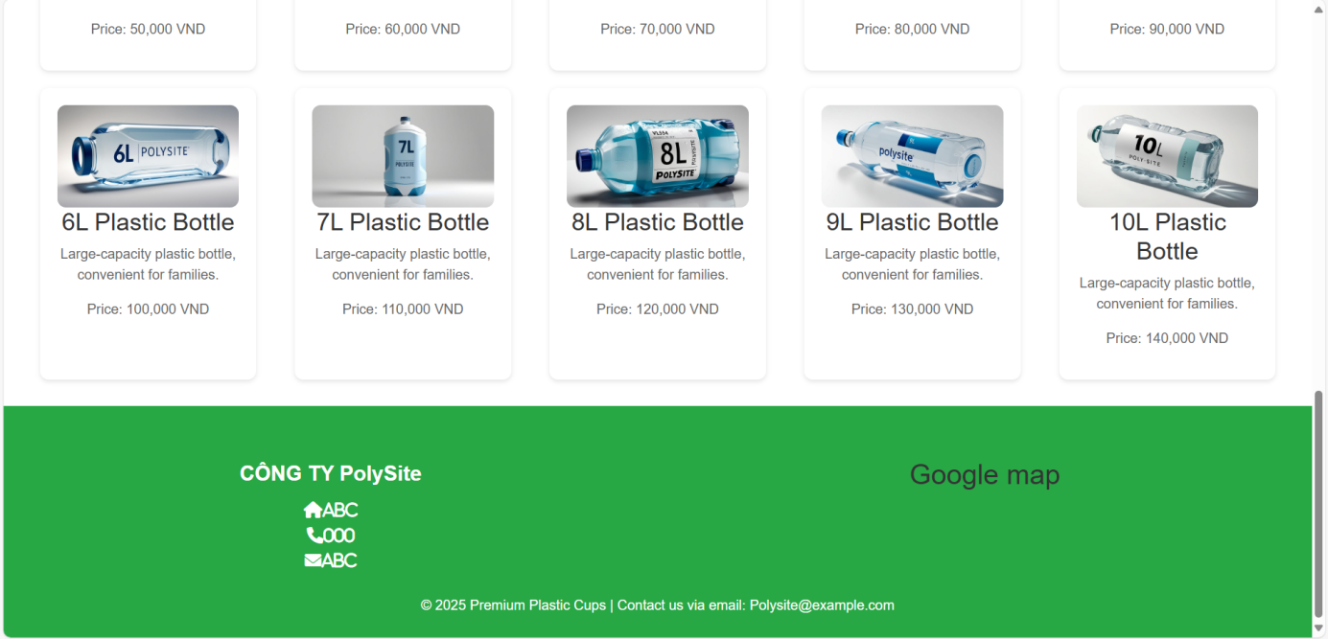**Description** : This is a website that contains an overview of PolySite's products

**From** : Open from any other page with a menu bar

**To :** From this website, the product detail page can be opened by clicking on the see more button in the description, any other website included in the menu bar

1. **Detail:**

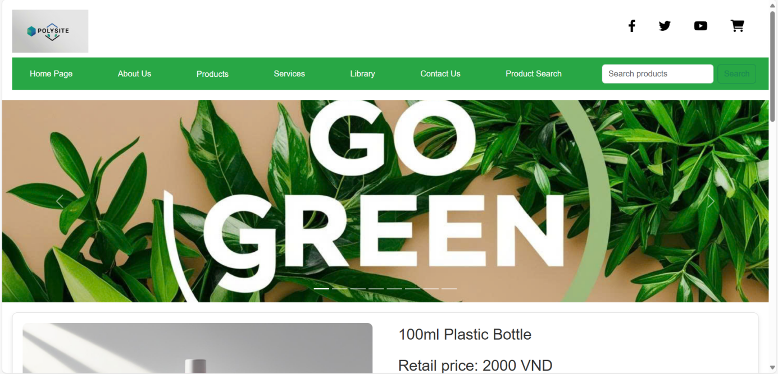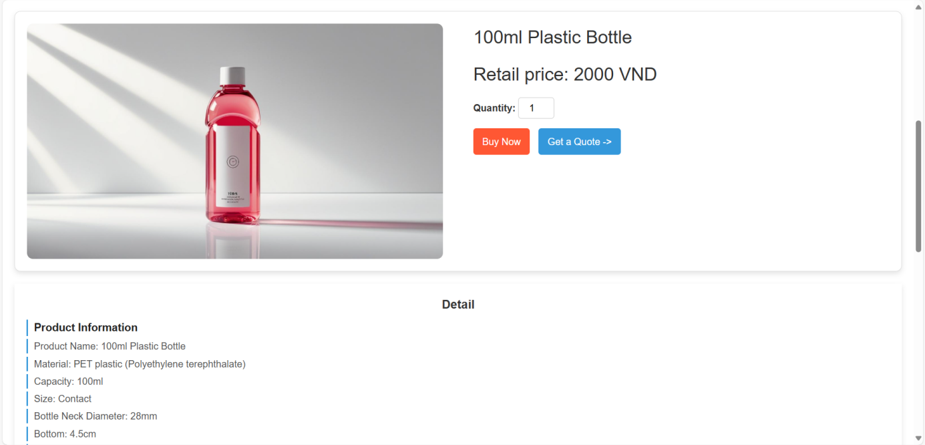

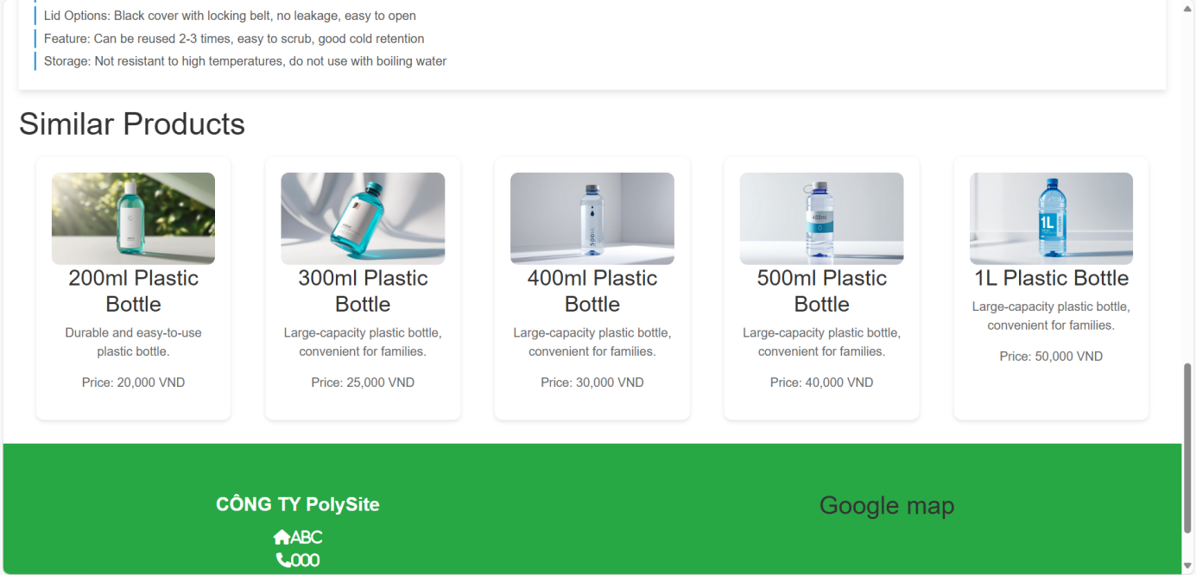**Description** : This is a website that contains detailed information about a specific product of the PolySite company

**From** : Opened from the products page by clicking on the “See More” button in the description

**To :** From this website it is possible to open any other website that is in the menu bar

1. **Contact Us and Feedback:**

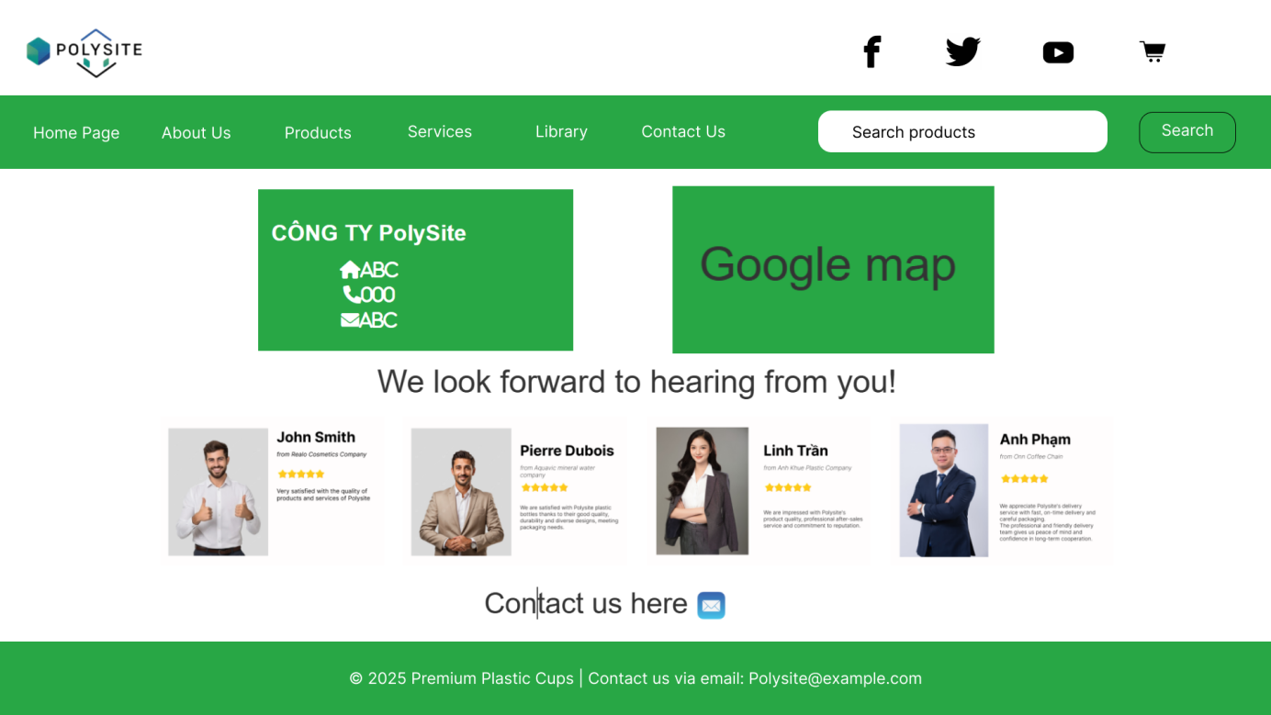

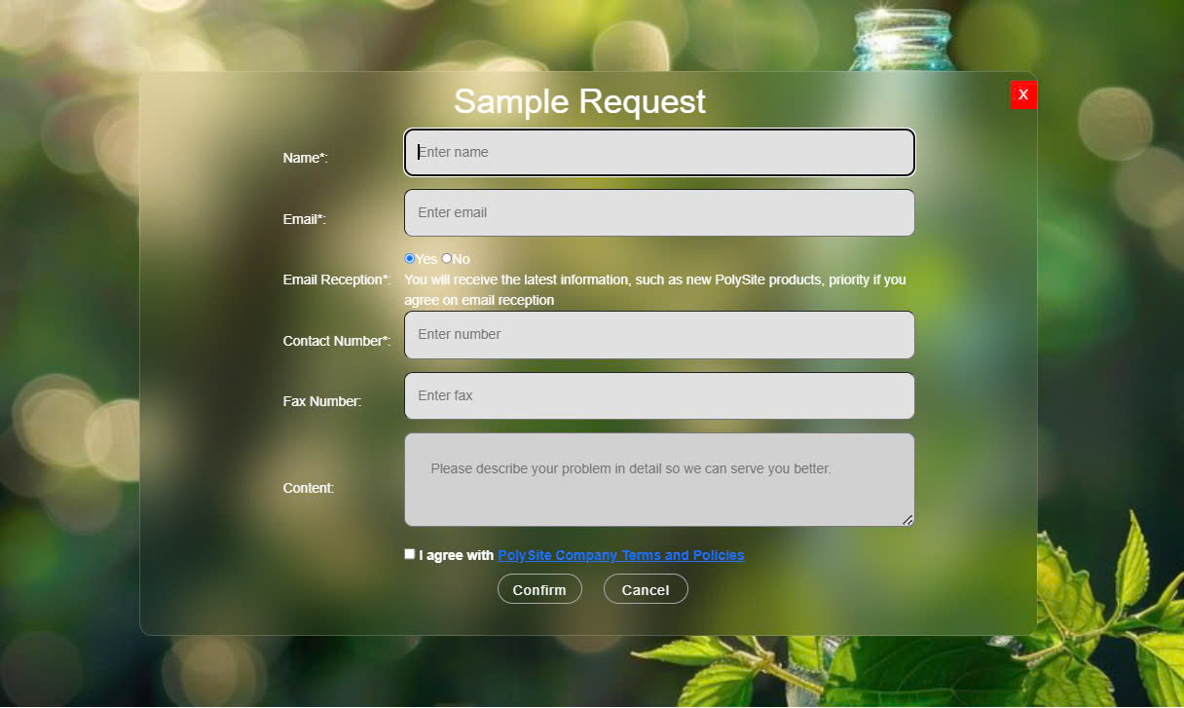

**Description** : This is the website containing the main contact recording form to the company via email. At the same time, it shows reviews from Polysite's partners. In addition, the footer also adds other contact information channels such as Facebook, Tiktok, Instagram, Switer.

**From** : Open from any other page with a menu bar

**To :** From this website it is possible to open any other website that is in the menu bar

1. **Services:**

|  |  |  |  |  |  |  |  |
| --- | --- | --- | --- | --- | --- | --- | --- |
| Logo | | | Icon Facebook | | Icon Twitter | Icon Youtube | Shopping Cart |
| Home | About Us | Products | Services | Library | | Contact Us | Product Search |
| Images and descriptions of services overview | | | | | | | |
| Contact Information | | | | Google API | | | |

**Description** : This website contains an overview of PolySite's services

**From** : Open from any other page with a menu bar

**To :** From this website it is possible to open Services Detail page and any other website that is in the menu bar

|  |  |  |  |  |  |  |  |
| --- | --- | --- | --- | --- | --- | --- | --- |
| Logo | | | Icon Facebook | Icon Twitter | | Icon Youtube | Shopping Cart |
| Home | About Us | Products | Services | | Library | Contact Us | Product Search |
| Image | | | | | | | |
| Service Description | | | | | | | |
| Contact Information | | | | | Google API | | |

1. **Services Detail:**

**Description:** This website contains detailed information about PolySite's services **From:** Open from any other page with a menu bar  
**To:** From this website it is possible to open any other website that is in the menu bar

1. **Library:**

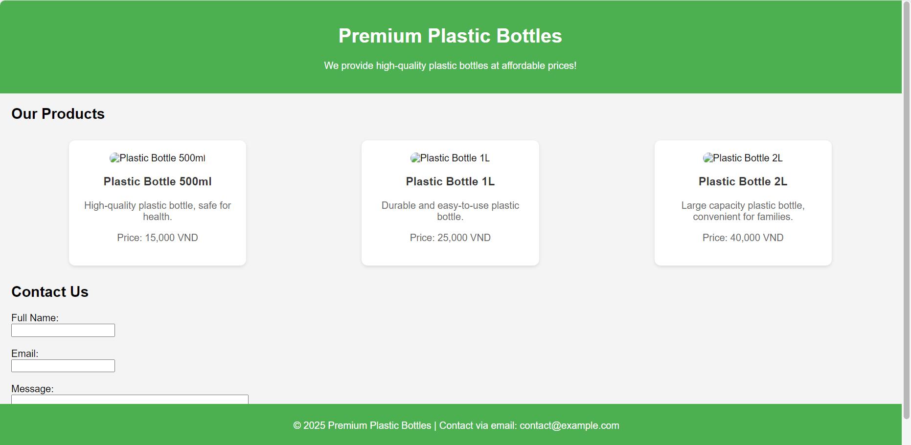

**Description:** Website contains images, basic information and prices of PolySite products **From:** Open from any other page with a menu bar  
**To:** From this website it is possible to open any other website that is in the menu bar

1. **Shopping Cart**

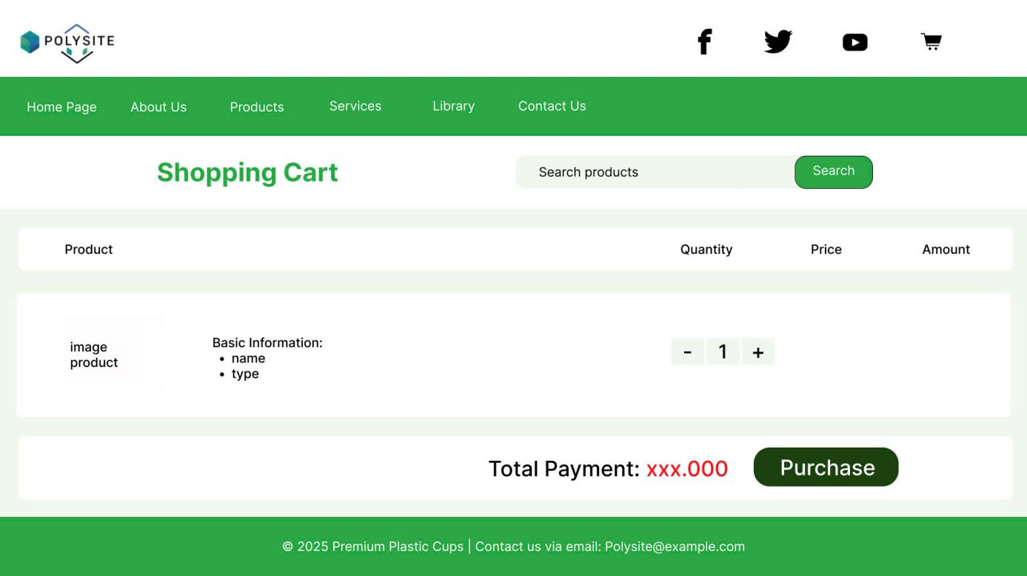

**Description:** This website contains information about the products that customers want to order **From:** Open from any other page with a menu bar  
**To:** From this website it is possible to open any other website that is in the menu bar

1. **Order**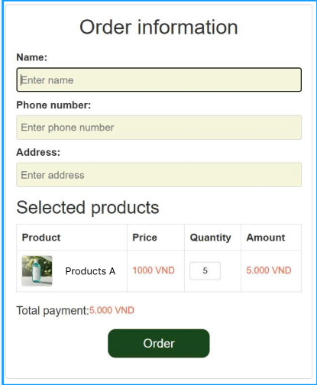

**Description:** This page is used for customers to enter their purchase information including name, phone number and address and review the list of products ordered **From:** Opens from the shopping cart page

**To:** From this page, the company will receive the customer's order information

|  |
| --- |
| **Checklist of Validation** |

|  |  |  |
| --- | --- | --- |
| **Sr.No** | **Features Tested** | **Remarks** |
| 1 |  |  |
| 2 |  |  |
| 3 |  |  |
| 4 |  |  |
| 5 |  |  |
| 6 |  |  |
| 7 |  |  |
| 8 |  |  |
| 9 |  |  |
| 10 |  |  |
| 11 |  |  |
| 12 |  |  |
| 13 |  |  |
| 14 |  |  |
| 15 |  |  |

|  |
| --- |
| **Submit checklist** |

|  |  |  |
| --- | --- | --- |
| **Sr.No** | **Aspected Tested** | **Suggestion/**  **Remarks** |
| 1 | Are all the users able to view the images and links? |  |
| 2 | Have all the views, modules and controllers been properly integrated and is the site function as a single page application? |  |
| 3 | Are the GUI content devoid of spelling mistakes? |  |
| 4 | Is the application user-friendly? |  |
| 5 | Is the Website launching correctly in all popular browsers? |  |
| 6 | Are all the forms validated with proper criteria? |  |
| 7 | Do all text links lead to the appropriate website? |  |
| 8 | Do all image links lead to the appropriate website? |  |
| 9 | Are all the images and links clearly visible on the page? |  |
| 10 | Does the Web page work properly in all the tested browsers? |  |
| 11 | Does the Web page take too long to be loaded fully? |  |
| 12 | Is the navigation sequences correct through all the Web pages on the site? |  |
| 13 | Is the JavaScript code working as expected in all click events? |  |
|  |  |  |

|  |  |  |  |  |  |  |  |
| --- | --- | --- | --- | --- | --- | --- | --- |
| **No** | **Member** | **Contents** | **Page Name** | **Activity Plan** | **Date of Preparation of Activity Plan** | | |
| **Planed Start Date** | **Actual Start Date** | **Actual Days** | **Status** |
| 1 | Huỳnh Quốc Huy | Homepage | Homepage.jsx  Search.jsx  Latest News.jsx | 15-02-2025 | 19-02-2025 | 5 | OK |
| 2 | Lê Trung Hiếu | Service  Library | Service.jsx  Library.jsx  Service Detail.jsx | 15-02-2025 | 19-02-2025 | 5 | OK |
| 3 | Trần Hoàng Anh | About Us  Product  Layout | About Us.jsx  Product.jsx  Product Detail.jsx  Layout.jsx  Navbar.jsx  Carousel.jsx  Footer.jsx | 15-02-2025 | 19-02-2025 | 5 | OK |
| 4 | Lê Thị Hạnh Mai | Contact Us and  Feedback | Contact.jsx  Feedback.jsx  Shopping Cart.jsx Order.jsx | 15-02-2025 | 19-02-2025 | 5 | OK |